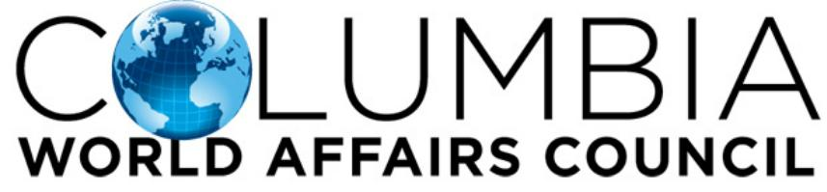
CWAC Event Proposal

Full Name
Email
Contact Number
Circle Event of Interest | Coffee & Conversations | Happy Hour  Guest Speaker | Info Session/Class | Other
If Other, Suggested Title for Event
Purpose of Event (less than 20 words)

How do you plan to create dialogue at your event?

Expected # of Participants (Estimate)
Would you like to limit attendance to a certain number? *
Suggested Location, Date, Time, if known**

Instructions for Next Step | - Complete and submit event planning document  - Confirm event time/date with CWAC staff  - Promote the event via email/social media  - As we will promote your event, please share our post so we will be able to tag and notify you once it goes live.  - Pick up our resource basket and sign-in sheets at the CWAC office: 2218 Divine Street, Columbia; please drop off at the same location within one week of the event.
* If so, this will be the host responsibility for RSVP; Not recommended unless space is limited.
** For Coffee and Conversations, we recommend the following quarterly dates: Oct. 15 for 2019 and Feb. 4, May 5, Aug. 4, Nov. 3 for 2020. For a Happy Hour event, you may also consider helping plan our ‘New Member Happy Hours’ in 2020 on January 7, April 7, July 7 and October 6. Additional Happy Hours will be approved at the discretion of CWAC leadership.

