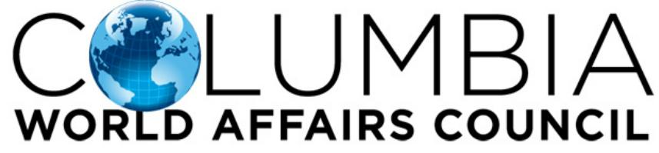
Guideline and Recommendations for Language Conversation Groups

- Meet-ups recommended for Adults (18 and over)
- Our primary commitment is to provide participants of similar interests an inclusive platform to learn and meet one another.
- Respect others’ right to hold opinions and beliefs that differ from your own.
- Be courteous. Do not interrupt or engage in private conversations while others are speaking.
- Be respectful and patient with other participants as participants may be at different language-specific levels in communication.
- Engage in introductions to familiarize with the group with active and new participants.
- Set expectations for the purpose of each group meeting.
- Notify CWAC with date, time, and location for confirmation.
- Promote the event via email/social media.
  - As CWAC will promote your event, please share our event to your timeline rather than creating your own event. We will tag and notify you once it goes live.
- If you have any questions or feedback, notify the group leader or CWAC.

Recommendations for Group Leaders:
  - Plan ahead of time for your event to make sure date, time, and location is confirmed; for location, call in advance at event location to make sure that space will not be limited
  - Keep tabs on headcount estimates and collect general contact information (ex. Google Forms, Microsoft Excel)
  - Collaborate with other language-related organizations in the area to attract interested participants
  - Attend CWAC ‘New Member Info Sessions’ to educate new members on conversation group meeting times and opportunities. CWAC will contact you as new sessions are announced.
  - Plan at least one meeting a month to keep group active
  - Have holiday-related meet-ups

For questions or comments, contact programs@columbiaworldaffairs.org or call us at 803) 252-2197. You may reach Executive Director Dickson Monk at dmonk@columbiaworldaffairs.org

